

Practices for Secure Software Report

Table of Contents
Document Revision History 3
Client 3
Instructions 3
Developer 4
1. Algorithm Cipher 4
2. Certificate Generation 4
3. Deploy Cipher 4
4. Secure Communications 4
5. Secondary Testing 4
6. Functional Testing 4
7. Summary 4
8. Industry Standard Best Practices 4

Document Revision History

Version | Date | Author | Comments
1.0 | [Date] | [Your Name]

Client



Instructions

Submit this completed practices for secure software report. Replace the bracketed text with the relevant information. You must document your process for writing secure communications and refactoring code that complies with software security testing protocols.

- Respond to the steps outlined below and include your findings.
- Respond using your own words. You may also choose to include images or supporting materials. If you include them, make certain to insert them in all the relevant locations in the document.
- Refer to the Project Two Guidelines and Rubric for more detailed instructions about each section of the template.

Developer
Darren Sweely

Algorithm Cipher
For Artemis Financial, I chose SHA-256 as the hashing algorithm for the checksum verification. SHA-256 is appropriate because it creates a 256-bit hash value that can be used to verify that data has not been changed. This is important for Artemis Financial because the company handles sensitive financial information and needs a reliable way to verify data integrity. If the original data is changed, even slightly, the resulting checksum will also change, which can help identify unauthorized modification or corruption.
SHA-256 is a hashing algorithm rather than an encryption algorithm. Encryption is designed to protect confidentiality and can be reversed with the correct key, while a cryptographic hash is a one-way function used to verify integrity. For this application, the goal of the checksum is not to recover the original data from the hash but to compare hash values and determine whether the data has remained unchanged.
I implemented SHA-256 using Java's built-in MessageDigest class instead of adding another third-party dependency. This allowed the application to generate the checksum using functionality already provided by Java and avoided introducing another external library that would need to be maintained and checked for vulnerabilities. The checksum was implemented in SslServerApplication.java and tested using the unique data string "Darren Sweely - Artemis Financial Secure Data 2026."

Certificate Generation
Insert a screenshot below of the CER file.

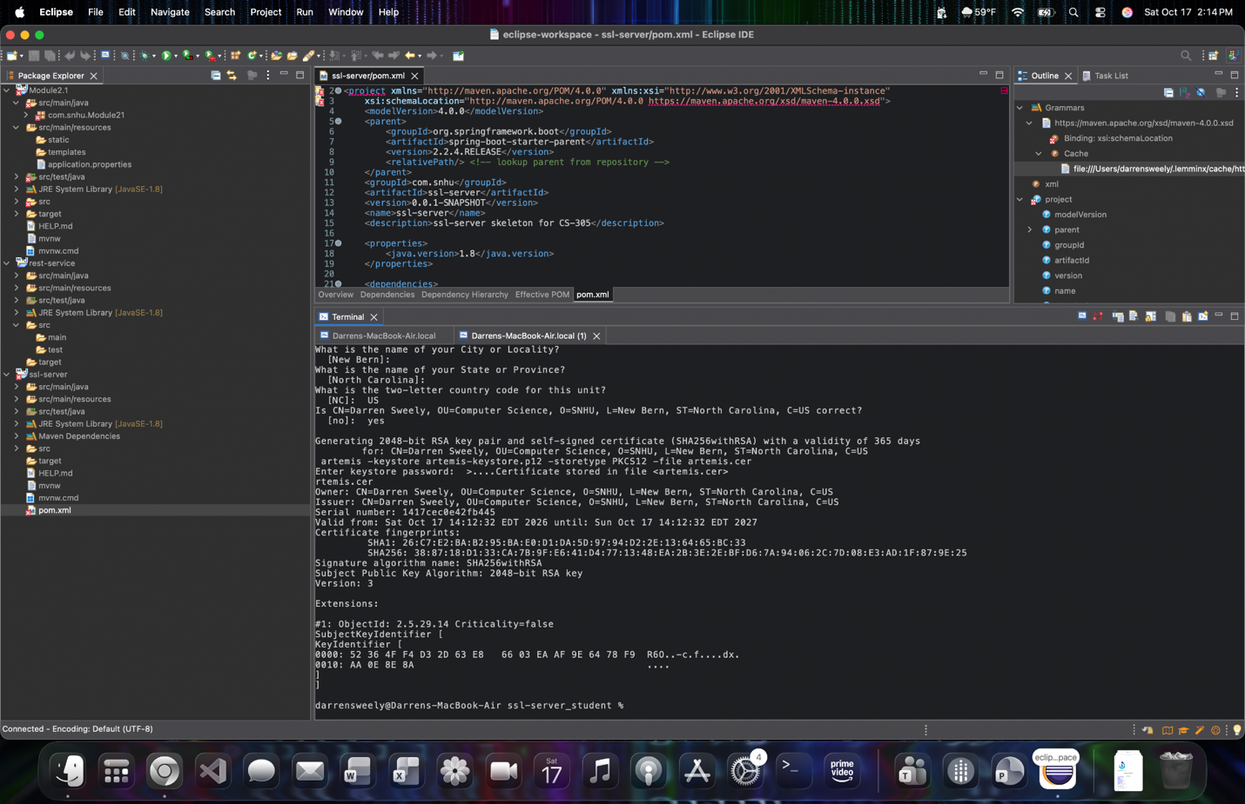
Figure 1. Self-signed certificate generated with Java Keytool and exported as artemis.cer. The certificate uses a 2048-bit RSA public key with the SHA256withRSA signature algorithm.

Deploy Cipher
Insert a screenshot below of the checksum verification.

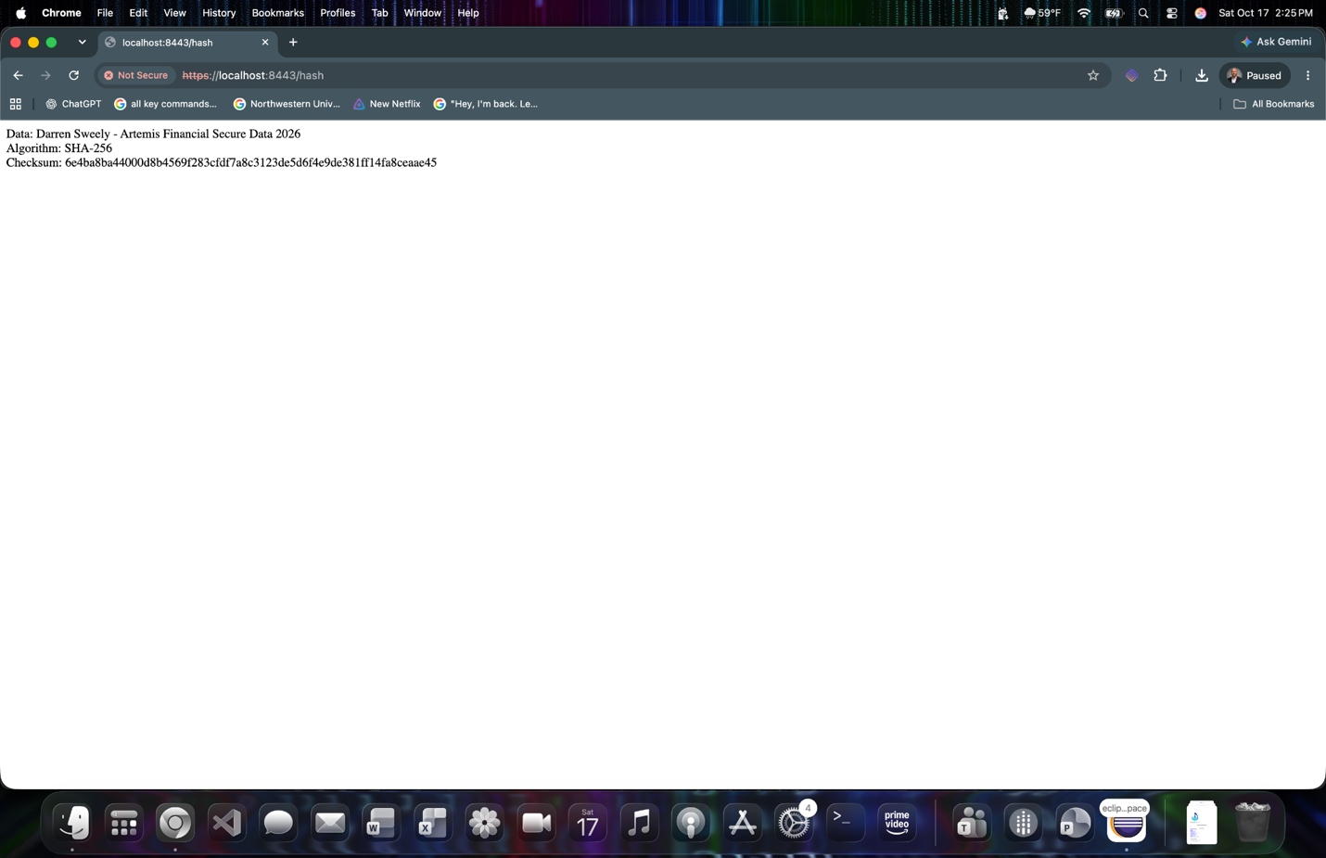
Figure 2. SHA-256 checksum verification for the unique data string “Darren Sweely - Artemis Financial Secure Data 2026.” The application generated the checksum using Java’s MessageDigest class.

Secure Communications
Insert a screenshot below of the web browser that shows a secure webpage.

Figure 3. The refactored application accessed through HTTPS at https://localhost:8443/hash using the self-signed certificate created for Artemis Financial. Chrome identifies the certificate as untrusted because it is self-signed rather than issued by a trusted certificate authority.

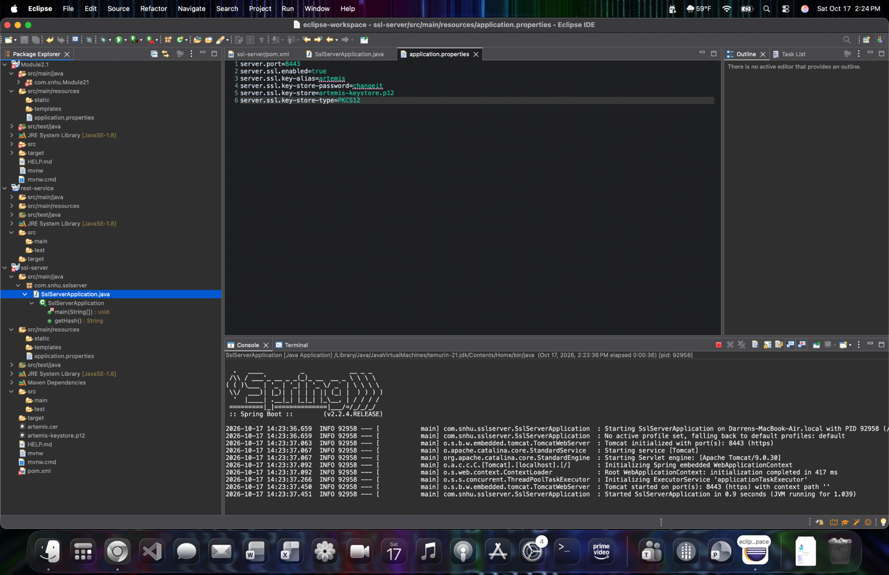
Figure 4. Eclipse console output confirming that the Spring Boot application successfully started Tomcat on port 8443 using HTTPS.

Secondary Testing
Insert screenshots below of the refactored code executed without errors and the dependency-check report.

Figure 5. Refactored ssl-server application executing successfully in Eclipse. The console confirms that the application started without errors and that Tomcat is running on port 8443 using HTTPS.

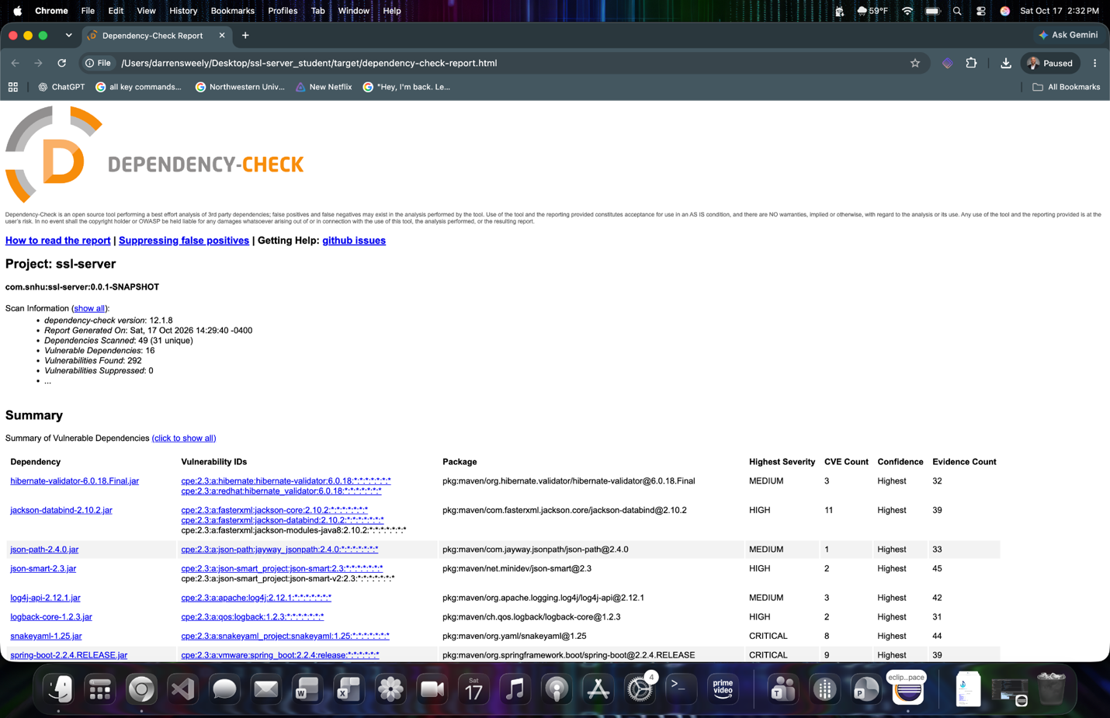
Figure 6. OWASP Dependency-Check 12.1.8 results for the refactored ssl-server project. The scan reviewed 49 dependencies (31 unique) and identified 16 vulnerable dependencies containing 292 known vulnerabilities.

Functional Testing
Insert a screenshot below of the refactored code executed without errors.

Figure 7. Functional testing of the refactored ssl-server application. The Eclipse console shows that the application executed successfully without errors and that Tomcat started on port 8443 using HTTPS.

Functional testing confirmed that the refactored application continued to operate correctly after the security changes were implemented. The application started without errors, established the HTTPS service on port 8443, and successfully returned the SHA-256 checksum through the /hash endpoint. I also verified the endpoint a second time using the same input data and received the same checksum, confirming that the hashing function continued to produce the expected result.

Summary

I refactored the Artemis Financial application to improve the security of its communications and provide a way to verify data integrity. I implemented SHA-256 checksum generation in SslServerApplication.java using Java’s MessageDigest class. The checksum endpoint uses the unique data string “Darren Sweely - Artemis Financial Secure Data 2026” and consistently produced the SHA-256 checksum 6e4ba8ba44000d8b4569f283cfdf7a8c3123de5d6f4e9de381ff14fa8ceaae45 during testing. I also generated a self-signed certificate with Java Keytool using a 2048-bit RSA key and the SHA256withRSA signature algorithm.
I then configured application.properties to use the PKCS12 keystore and changed the application to communicate over HTTPS on port 8443. Testing confirmed that Tomcat successfully started using HTTPS and that the /hash endpoint could be reached at https://localhost:8443/hash. The browser displayed the self-signed certificate as untrusted because it was not issued by a public certificate authority, which is expected for the locally generated certificate used in this project.
After completing the refactoring, I performed secondary testing with OWASP Dependency-Check 12.1.8. The scan reviewed 49 dependencies, including 31 unique dependencies, and identified 16 vulnerable dependencies containing 292 known vulnerabilities. The report included Critical and High severity findings in older components provided with the project, including SnakeYAML and Spring Boot. My security changes did not add additional Maven dependencies because the SHA-256 implementation uses Java’s built-in cryptographic functionality and HTTPS uses the generated keystore. These existing dependency findings should still be addressed by updating the outdated libraries, beginning with Critical and High severity vulnerabilities.
Overall, the refactoring improved the application by adding data-integrity verification and encrypted HTTPS communication while maintaining the original application functionality. Functional testing showed that the application executed without errors and continued to return the expected checksum after the security changes were implemented. The remaining Dependency-Check findings show that secure software development also requires continued dependency maintenance in addition to secure coding and communication practices.

Industry Standard Best Practices

Artemis Financial should continue using a layered approach to application security instead of relying on one security control. HTTPS should be required for communications that contain sensitive financial or customer information so that data is protected while it is being transmitted. In a production environment, the self-signed certificate used for this project should be replaced with a certificate issued by a trusted certificate authority. Certificates and private keys should also be stored securely, monitored for expiration, and replaced before they expire.
Cryptographic algorithms should follow current industry standards and should not be implemented using custom cryptographic code when established libraries are available. SHA-256 is appropriate for the checksum verification used in this application because it provides a strong cryptographic hash for detecting changes to data. Java’s built-in MessageDigest implementation also allowed me to add this functionality without introducing another third-party dependency. For security functions that require encryption rather than hashing, Artemis Financial should use current, approved encryption algorithms and properly manage the encryption keys throughout their lifecycle.
Dependency management should also be part of the normal development process. The OWASP Dependency-Check scan identified 16 vulnerable dependencies and 292 known vulnerabilities in the current project. Some of the older components, including SnakeYAML and Spring Boot, contained Critical severity findings. Artemis Financial should prioritize Critical and High severity vulnerabilities, determine whether updated dependency versions are compatible with the application, test those updates, and then address Medium and lower severity findings. Dependency scanning should be repeated whenever dependencies or application code are changed so that newly identified vulnerabilities can be addressed instead of remaining in the application.
Finally, secure coding should be included throughout the software development life cycle. This includes validating user input, using secure error handling, avoiding hard-coded credentials and other sensitive information, keeping dependencies updated, performing code reviews, and using automated security testing such as dependency scanning. Security testing should also be repeated after code changes to make sure that a security improvement in one area does not create a new problem somewhere else. Using these practices together would help Artemis Financial protect the confidentiality, integrity, and availability of its financial data while continuing to maintain and modernize the application.
References
National Institute of Standards and Technology. (2015). Secure Hash Standard (SHS) (FIPS PUB 180-4). U.S. Department of Commerce.
OWASP Foundation. (n.d.). OWASP Dependency-Check.
Oracle. (n.d.). Java cryptography architecture (JCA) reference guide.

